**Measure the diameter of the vessel**

**1.Introduction**

Measure the diameter of the vessel is a tool that can achieve some functions. It can measure the diameter of the vessel by identifying the image which is imaged by two-photon.

We can get a video (Fig.1a) when we use the two-photon to image the vessel. For example, if we want to measure the diameter of the vessel at the yellow line, we can get images of 200 frame (Fig.1b).

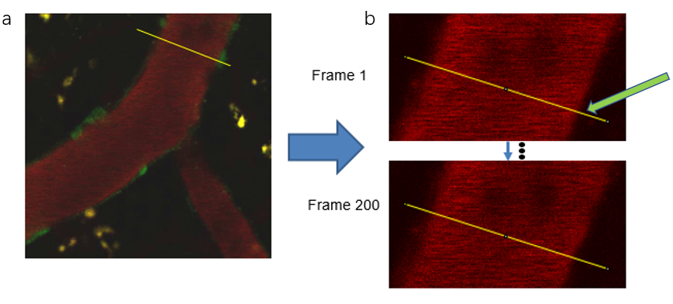

**Fig.1.** (a) The video imaged by two-photon.

(b) 200 frames of image at the yellow line

Then, we use ImageJ to extracts a row of pixels at the yellow line (Fig.1b The yellow line pointed at by the green arrow) and combine them into a single picture in chronological order (Fig.2a). Our code can analyze the pixels of each row (Fig.2b) using full-width-at-half-maximum to get the diameter of that place (Fig.2c).

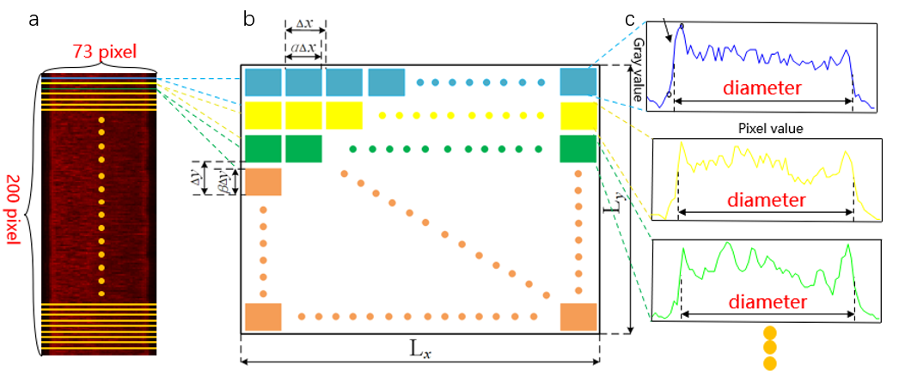

**Fig.2.** (a) The image combines a row of pixels at the yellow line of a 200-frame image in chronological order.

(b) Pattern graph of pixels per row.

(c) Grayscale value change of a row of pixels.

**2.System Requirements**

*Matlab R2021a or newer, earlier versions should also work but not tested.

**3.Usage**

First, run the example codes which are named ‘test.m’ to get the parameters required by the subsequent codes.

Example picture (Fig.3) is named ‘line1_red_rank0 bmp’.

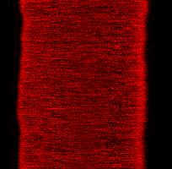

**Fig.3.** Example picture used to get parameter.

Then, run the example codes which are named ‘main.m’.

Example picture is named ‘line1_red_rank0 bmp ‘.

**4.1 Get parameter** (Run the example codes which are named ‘test.m’.) ( Please make a note of the resulting parameters for subsequent programs）

See the example 'test.m' as following:

First, modify the file path (E:\picture_test \line1_red_rank0.bmp') (at 3 lines)to fit your own picture: You can get the file path of the yellow section (E:\picture_test \line1_red_rank0.bmp') by doing the following (Fig.4). And you should change the file path of the green section (E:\picture_test \line1_red_rank0.bmp') to your own file name. You should pay special attention to whether you use a suffix name that is appropriate for your image file.

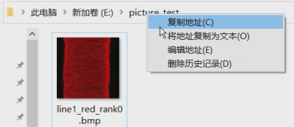

**Fig.4** File path extraction.

Second, run the codes to generate five figures as Fig.5 to determine the appropriate parameters（e value、baseline left、baseline right）.

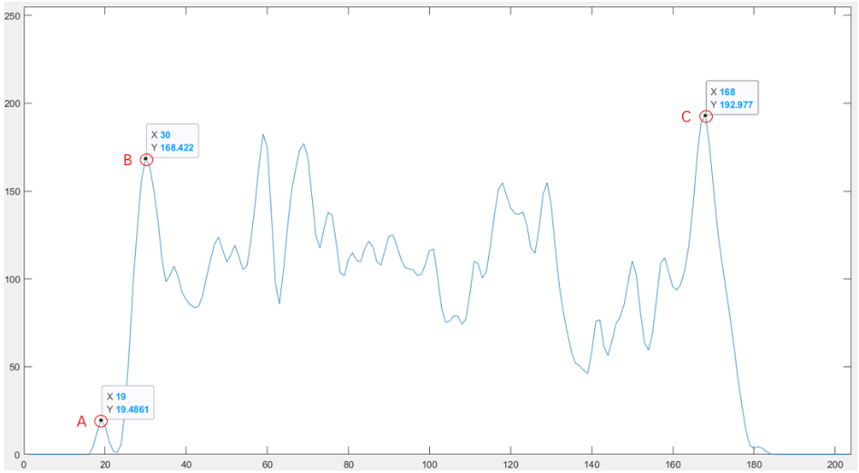

**Fig.5.** Grayscale value change of a row of pixels.

Determine e value according to the following rules:

(You can find point A, point B and point C in fig.5)

Get ‘e value’: e value >Y1 (point A) and e value <Y2 (point B) and e value <Y3 (point C)

(‘e value’ is used to eliminate small peaks like point A on both sides. An intermediate value for ‘e value’ is appreciated.)

(Attention: You should refer to all five figures before deciding on the appropriate parameters, which means you should make sure that these parameters conform to the above rules in all five figures.)

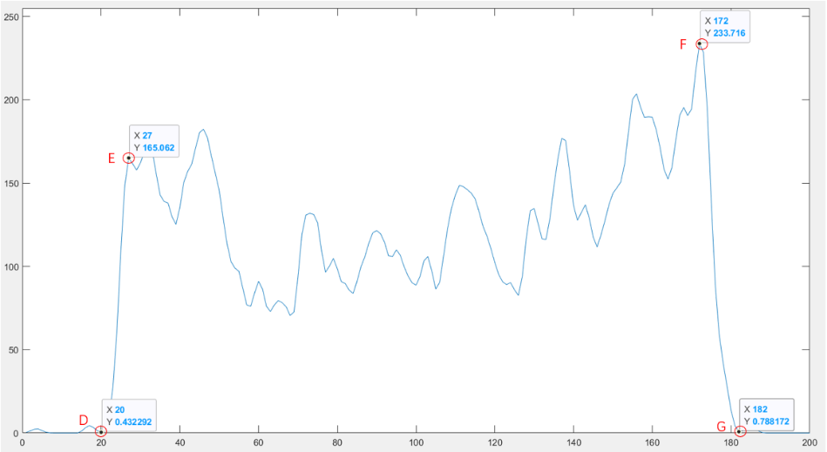

**Fig.6.** Grayscale value change of a row of pixels.

Determine ‘baseline left’ and ‘baseline right’ according to the following rules:

(You can find point D, point E, point F and point G in fig.6)

1. Get’ baseline left’: Y4 (point D) <’ baseline left’< Y5 (point E)

(The value of’ baseline left’ should be only a little bigger (1 or 2) than Y4 (point D))

1. Get’ baseline right’: Y6 (point G) <’ baseline right’< Y7 (point F)

(The value of’ baseline right’ should be only a little bigger (1 or 2) than Y6 (point G))

1. If you want, you can also change the parameter of the ‘gaussian’ to adapt your data.

(Increase the value to make the curve smoother or reduce the value to bring the curve closer to the original data)

(Attention: You should refer to all five figures before deciding on the appropriate parameters, which means you should make sure that these parameters conform to the above rules in all five figures.)

**4.2 Generate the diameter of the vessel** (Run the example codes which are named ‘main.m’.)

See the example 'main.m' as following:

First, change the parameters to the ones obtained in step 4.1 above.

1. Fill in the ‘e value’ value to the horizontal line (e_value= ___) (at 6 lines)
2. Fill in the ‘baseline left’ value to the horizontal line (baseline_left= ___) (at 7 lines)
3. Fill in the ‘baseline right’ value to the horizontal line (baseline_right= ___) (at 8 lines)
4. If you want, you can also change the parameter of the ‘gaussian’. Fill in the parameter to the horizontal line(c=smoothdata(b,'gaussian', ___) (at 25 lines)

Then, modify the file path (E:\picture_test \line1_red_rank0.bmp&apos;) (at 3 lines)to fit your own picture. (For details, please refer to 4.1)

Finally, run the codes to generate the figure of changes in the diameter of blood vessels as Fig.7. When the blood vessels are in a physiological state, if (number_negative + number_positive) < (rows*10%), we believe that the resulting data is credible. You can get the diameter of each frame image from the variable ‘diameter’.

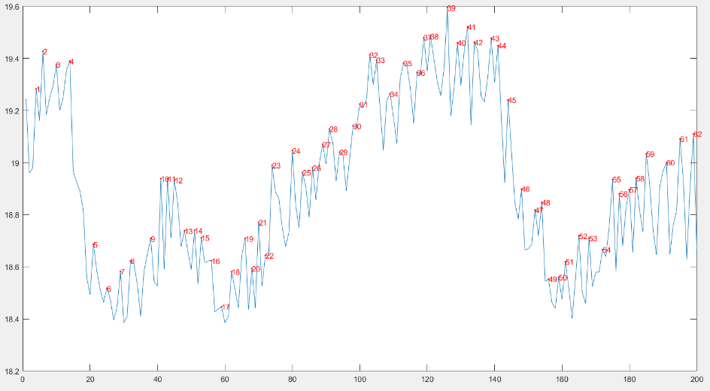

**Fig.7.** Blood vessel diameter change during 200 frames.

Update: 2022.9.21

Editor: Wen-Tao Wang Yi-yi Zhang Jin-ze Li

Laboratory leader: Jie-Min Jia